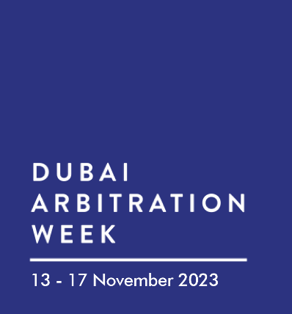

**Dubai Arbitration Week 2023 “Sponsorship Packages”**

**Diamond Sponsorship *(AED 25,000) inclusive of VAT 5%***

* Exclusive acknowledgement of your organization’s Diamond sponsorship status on the home page of the DAW website.
* 500-word corporate description featured on the DAW website.
* Sponsor's logo will be displayed on the Cocktail Reception's entrance and in all DAW 2023 marketing materials.
* Sponsor's logo will be included on the event program on the Dubai Arbitration Week website, along with a link to the sponsor page.
* Reservation at the DAW cocktail reception for up to ten [10] members of your organization or esteemed guests.
* Acknowledgement from the event's MC during the opening reception.
* 5 minutes speaking slot during the opening reception.
* Included in the ‘Thank you’ email post-conference to all attendees from the organizers.
* Opportunity to insert 3 promotional items into the giveaway bags distributed during the opening reception.

**Top of Form**

**Platinum Sponsorship *(AED 18,000) inclusive of VAT 5%***

* Exclusive acknowledgement of your organization’s Platinum sponsorship status on the home page of the DAW website.
* 350-word corporate description featured on the DAW website.
* Sponsor's logo will be displayed on the Cocktail Reception's entrance and in all DAW 2023 marketing materials.
* Sponsor's logo will be included on the event program on the Dubai Arbitration Week website, along with a link to the sponsor page.
* Reservation at the DAW cocktail reception for up to seven [7] members of your organization or esteemed guests.
* Acknowledgement from the event's MC during the opening reception.
* Included in the ‘Thank you’ email post-conference to all attendees from the organizers.
* Opportunity to insert 2 promotional items into the giveaway bags distributed during the opening reception.

**Gold Sponsorship *(AED 12,500) inclusive of VAT 5%***

* Exclusive acknowledgement of your organization’s Gold sponsorship status on the home page of the DAW website.
* 200-word corporate description featured on the DAW website.
* Sponsor's logo will be displayed on the Cocktail Reception's entrance and in all DAW 2023 marketing materials.
* Sponsor's logo will be included on the event program on the Dubai Arbitration Week website, along with a link to the sponsor page.
* Reservation at the DAW cocktail reception for up to five [5] members of your organization or esteemed guests.
* Included in the ‘Thank you’ email post-conference to all attendees from the organizers.
* Opportunity to insert 1 promotional item into the giveaway bags distributed during the opening reception.

**Silver Sponsorship *(AED 7,500) inclusive of VAT 5%***

* Exclusive acknowledgement of your organization’s Silver sponsorship status on the home page of the DAW website.
* 110-word corporate description featured on the DAW website.
* Sponsor's logo will be displayed on the Cocktail Reception's entrance and in all DAW 2023 marketing materials.
* Sponsor's logo will be included on the event program on the Dubai Arbitration Week website, along with a link to the sponsor page.
* Reservation at the DAW cocktail reception for up to three [3] members of your organization or esteemed guests.
* Included in the ‘Thank you’ email post-conference to all attendees from the organizers.